
East West University
Lab Report
Semester: Spring-2024
Course Title: Electronic Circuit Course Code: CSE251 Sec: 04

Expt No: 06
Expt Name: Signal Integration and Differentiation Using 741 Op-Amp Group No: 07
Group Members:

Student Name | Student Id
Sonia Bente Siraj | 2022-2-60-087
Pallob Nath | 2022-3-60-223
Md.Jubayer Hasan | 2022-2-60-042

Submitted By:
Student’s Name: Sonia Bente Siraj
Student’s ID: 2022-2-60-087
Submitted To:

Dr. Sarwar Jahan
Associate Professor
Department of CSE

Date of Submission: 10.09.2024

Objective:
In this experiment, we are going to study the responses of Op-Amp integrators to sinusoid and square waveforms and also the responses of Op-Amp differentiators to sinusoid and triangular waveforms.

Components Needed:

- Digital trainer board
- Signal generator
- Oscilloscope
- Digital multimeter
- 741 op amp (1 pc)
- Resistor(1K 1 pc)
- Capacitor
- Breadboard
- Connecting wires

THEORY AND EXPERIMENTAL METHODS:

For Integrate,V_{o} = (1/ຜRC) V_{in} For Differentiator,V_{o} = ຜRC V_{in}

Pre-Lab Question:

- Here,

R = 1 KΩ
C = 0.1µF = 0.1 × 10⁻⁶ F Vp = 2V
f =1000 Hz

We Know, Amplitude, V_{o} = V_{p}/ຜRC
= V_{p}/2πfRC
= 2/(2 x 3.1416 x 1000 x 1000 x 0.1 x 10⁻⁶)
= 3.18 V

Here,
R = 1 KΩ
C = 0.1µF = 0.1 × 10⁻⁶ F Vp = 2V
f =1000 Hz

We Know, Amplitude, V_{o} = ຜRCV_{p}
= 2πfRCV_{p}

= 2 x 3.1416 x 1000 x 1000 x 0.1 x 10⁻⁶ x 2
= 1.25 V
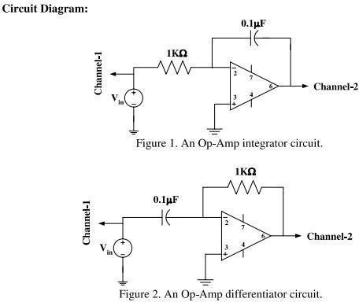

POST LAB REPORT QUESTIONs & ANSWER
INTEGRATOR:
(1) In the output expression from your prelab, put the measured value of R and the given values of C and Vp; calculate the amplitude of the output signal and compare it with the measured data.

Solution:
Here, R = 0.9 KΩ
C = 0.1µF = 0.1 × 10⁻⁶ F Vp = 2V
f =796.18 Hz

We Know, Amplitude, V_{o} = V_{p}/ຜRC
= V_{p}/2πfRC
= 2/(2 x 3.1416 x 1000 x 1000 x 0.1 x 10⁻⁶)
= 3.18V

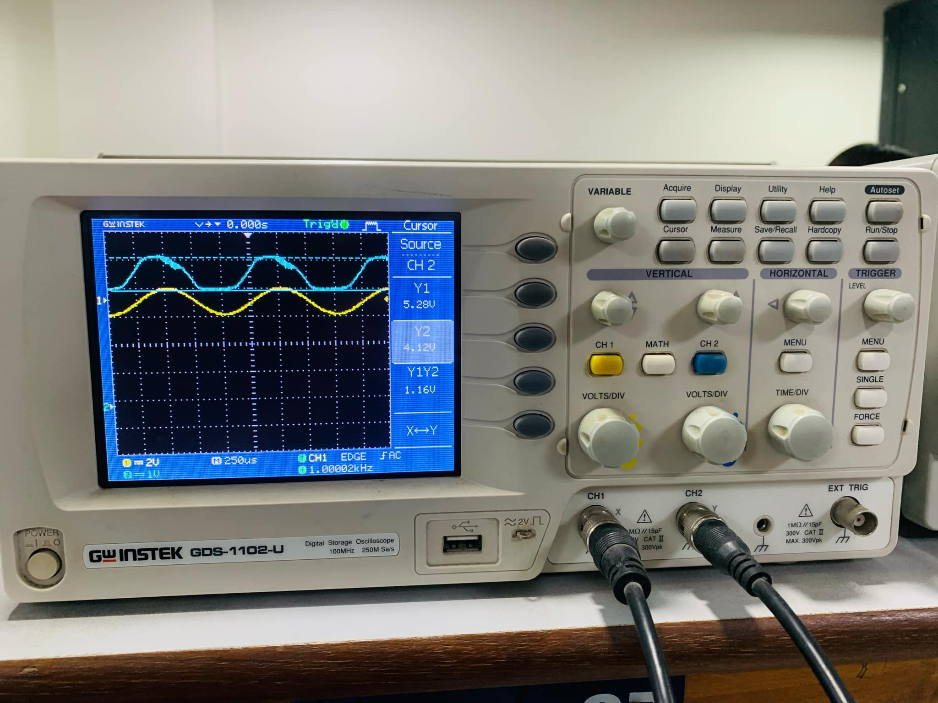
- Simulate the integrator of Figure 1 for 4 cycles using PSpice with the measured value of R and the square wave input that you have used in the lab and have the simulation result printed. Compare the simulation result with your measurement

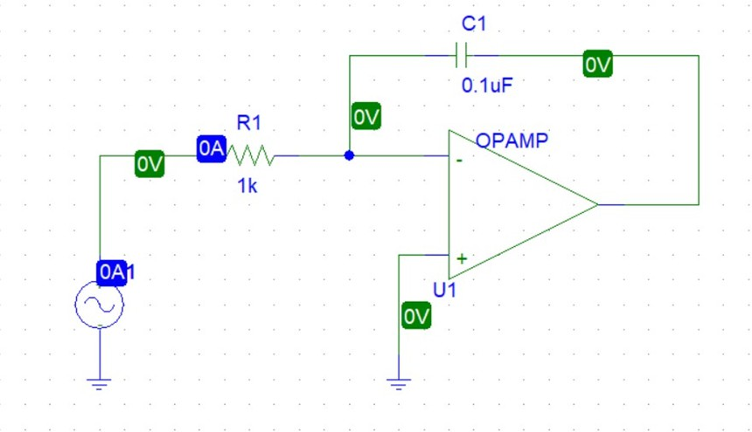

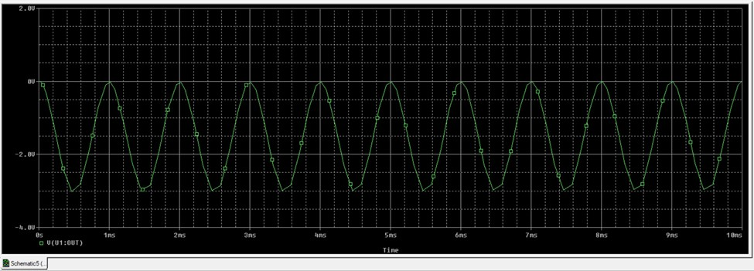

DIFFERENTIATOR:
- In the output expression from your prelab, put the measure value of R and the given values of C and Vp; calculate the amplitude of the output signal and compare it with the measured data.
Solution:

Here,

R = 1 KΩ
C = 0.1µF = 0.1 × 10⁻⁶ F Vp = 2V
f =1000 Hz

We Know, Amplitude, V_{o} = ຜRCV_{p}
= 2πfRCV_{p}

= 2 x 3.1416 x 1000 x 1000 x 0.1 x 10⁻⁶ x 2
= 1.25 V

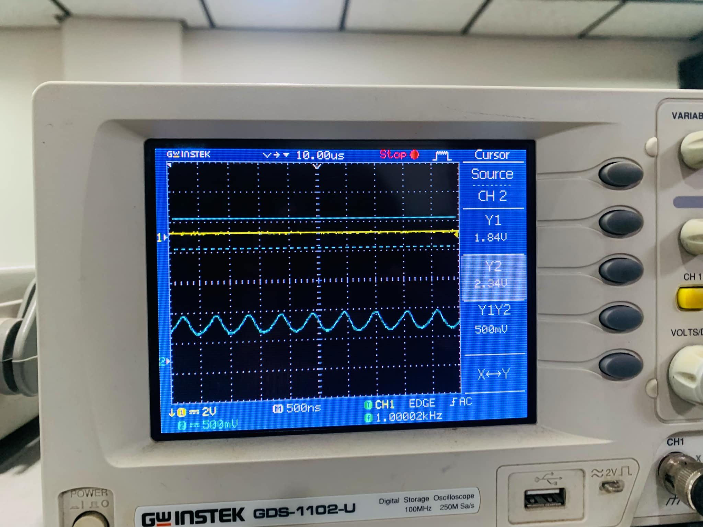

(5).Simulate the differentiator of Figure 2 for 4 cycles using PSpice with the measured value of R and the triangular wave input that you have used in the lab and have the simulation result printed. Compare the simulation result with your measurement.

